**Thyrodynamics: Dynamic visualization of Thyroid Health**

Thyroid disease represents a significant public health burden globally, affecting individuals of all ages and demographics. By gaining a comprehensive understanding of thyroid disorders, this project aims to inform healthcare professionals, policymakers, and the general public about the latest advancements in the field and contribute to improved diagnosis, treatment, and management of thyroid disease, ultimately enhancing patient outcomes and quality of life

Thyroid disease encompasses a spectrum of disorders affecting the thyroid gland, ranging from hyperthyroidism to hypothyroidism, thyroid nodules, and thyroid cancer. This project aims to delve deep into the various facets of thyroid disease, exploring its epidemiology, etiology, pathophysiology, clinical manifestations, diagnostic approaches, treatment modalities, and potential avenues for future research.

These activities collectively establish a robust foundation for the project, ensuring a comprehensive understanding of the problem domain, aligning project objectives with business goals, and setting the stage for impactful data analysis and visualization using Tableau.

**Section 1:** Patient Education and Consultation: Thyrodynamics could be used in a clinical setting to provide patients with dynamic visualizations of their thyroid health. During consultations, healthcare providers could use the dynamic visualization to explain various aspects of thyroid function, such as hormone production, regulation, and the effects of thyroid disorders. This interactive tool could help patients better understand their condition and treatment options, leading to more informed decision-making and improved adherence to treatment plans.

**Section 2:** Monitoring Thyroid Function Over Time: Thyrodynamics could also be utilized for longitudinal monitoring of thyroid function in patients with thyroid disorders. By regularly visualizing changes in thyroid hormone levels and gland activity over time, healthcare providers can track disease progression, assess the effectiveness of treatment interventions, and make adjustments as needed. This continuous monitoring can help optimize patient care and improve outcomes by detecting abnormalities early and preventing complications associated with thyroid disorders.

**Section 3:** Medical Education and Training: Thyrodynamics could serve as a valuable educational tool for medical students, residents, and healthcare professionals learning about thyroid physiology and pathology. Through interactive simulations and dynamic visualizations, learners can explore the complex dynamics of thyroid function in real-time, gaining a deeper understanding of the mechanisms underlying thyroid disorders and their clinical manifestations. This immersive learning experience can enhance medical education curricula, foster critical thinking skills, and ultimately improve the quality of patient care provided by future generations of healthcare professionals.

# Technical Architecture:

The technical architecture involves leveraging the data analytics capabilities of Tableau for visualizations and analysis. The architecture comprises several components to ensure efficient data processing and visualization.

At the core of the architecture is the data infrastructure, which includes data sources such as market reports, economic indicators, and surveys conducted among iPhone users in India. These data sources are collected and stored in a structured format for further analysis. Tableau is used as the primary data visualization tool. It connects to the data sources and allows for data extraction, transformation, and loading (ETL) processes. Tableau's intuitive interface enables users to create interactive and visually appealing visualizations, charts, and dashboards based on the analyzed data.

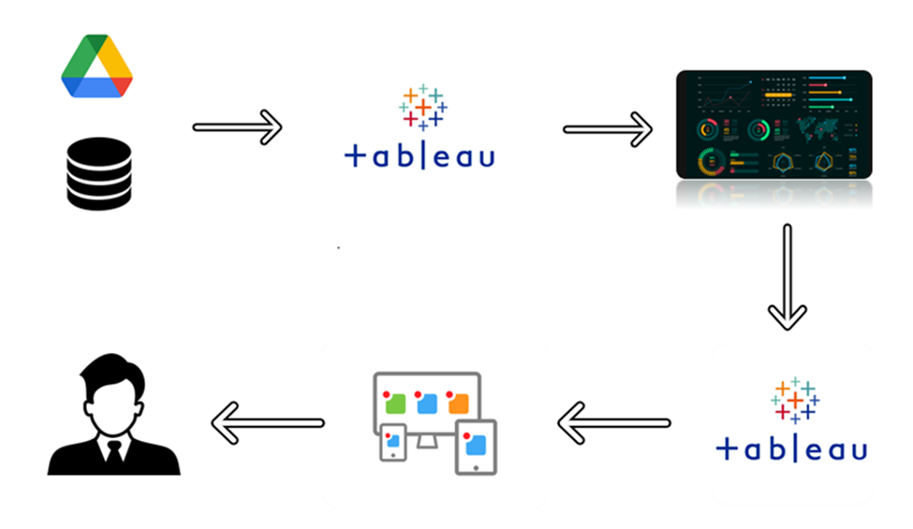

# Project Flow:

To accomplish this, we have to complete all the activities listed below,

* + Data Collection & Extraction
    - Collect the dataset
    - Connect Dataset with Tableau
  + Data Preparation
    - Prepare the Data for Visualization
  + Data Visualizations
    - No of Unique Visualizations
  + Dashboard
    - Responsive and Design of Dashboard
  + Story
    - No of Scenes of Story
  + Performance Testing
    - Utilization of Data Filters
    - No of Calculation Fields
    - No of Visualizations/ Graphs
  + Publishing
    - Publishing Dashboard and Story to Tableau Public
  + Project Demonstration & Documentation
    - Record explanation Video for project end to end solution
    - Project Documentation-Step by step project development procedure

# Milestone 1: Data Collection and Preparation:

Data collection is the process of gathering and measuring information on variables of interest, in an

established systematic fashion that enables one to answer stated research questions, test hypotheses, and evaluate outcomes and generate insights from the data.

## Activity 1: Collect the dataset

Please use the link to download the dataset:

## <https://www.kaggle.com/datasets/yasserhessein/thyroid-disease-data-set/data>

## Activity 2: Connect datasets with Tableau

**Reference video link:**

[**https://drive.google.com/file/d/1aTevYc13uZl28RROhpXwR_0Z2ElhX_BR/view?usp=sharing**](https://drive.google.com/file/d/1aTevYc13uZl28RROhpXwR_0Z2ElhX_BR/view?usp=sharing)

# Milestone 2: Data Preparation

## Activity 1: Prepare the Data for Visualization

Data modules are containers that describe data and rules for combining and shaping data to prepare it for analysis and visualization in Tableau. Data module sources. Data modules can be based on data servers, packages, uploaded ﬁles, data sets, and other data modules.

**Activity 2: Data cleaning**

**Reference video Link:**

[**https://drive.google.com/file/d/1VKgjkJFYumqux1LC_dkJXS7h-ZHz0uy4/view?usp=sharing**](https://drive.google.com/file/d/1VKgjkJFYumqux1LC_dkJXS7h-ZHz0uy4/view?usp=sharing)

# Milestone 3: Data Visualization

Data visualization is the process of creating graphical representations of data in order to help people understand and explore the information. The goal of data visualization is to make complex data sets more accessible, intuitive, and easier to interpret. By using visual elements such as charts, graphs, and maps, data visualizations can help people quickly identify patterns, trends, and outliers in the data.

## Activity 1: No of Unique Visualizations

The number of unique visualizations that can be created with a given dataset. Some common types of visualizations that can be used to analyze the performance and eﬃciency of a project include bar charts, line charts, heat maps, scatter plots, pie charts, Maps, etc. These visualizations can be used

to compare performance, track changes over time, and show distribution, and relationships between variables.

**Activity 1.1: KPI**

**Explanation video link:** [**https://drive.google.com/file/d/1XDFm7ucU13u-nuinQqq7nPWjIdgVFDC-/view?usp=sharing**](https://drive.google.com/file/d/1XDFm7ucU13u-nuinQqq7nPWjIdgVFDC-/view?usp=sharing)

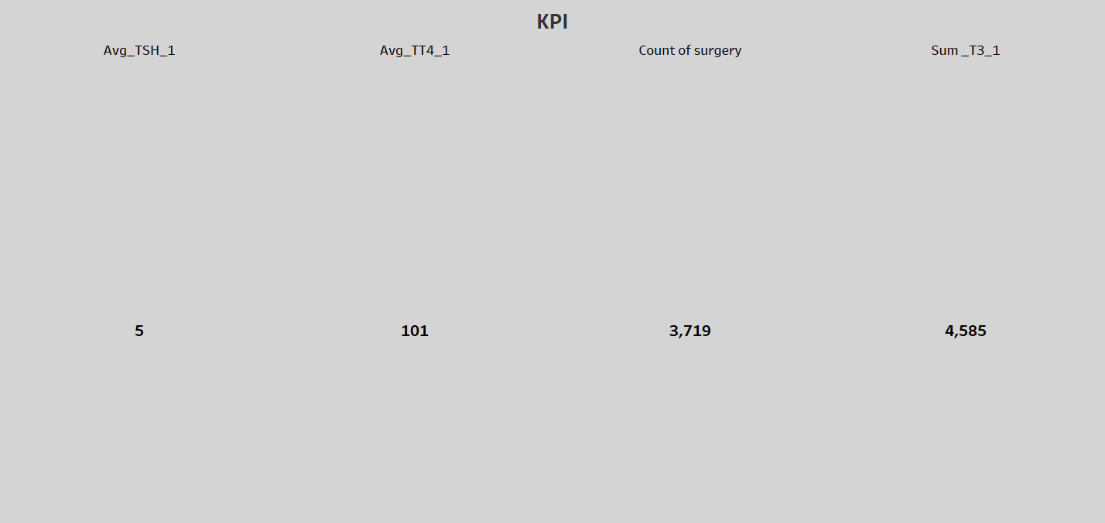

**Activity 1.2:**

**explanation link:** gender by surgery rate using donut chart.

[**https://drive.google.com/file/d/10ZedkslPXqy_3bLo0BvWTSvNk_WXD8F7/view?usp=sharing**](https://drive.google.com/file/d/10ZedkslPXqy_3bLo0BvWTSvNk_WXD8F7/view?usp=sharing)

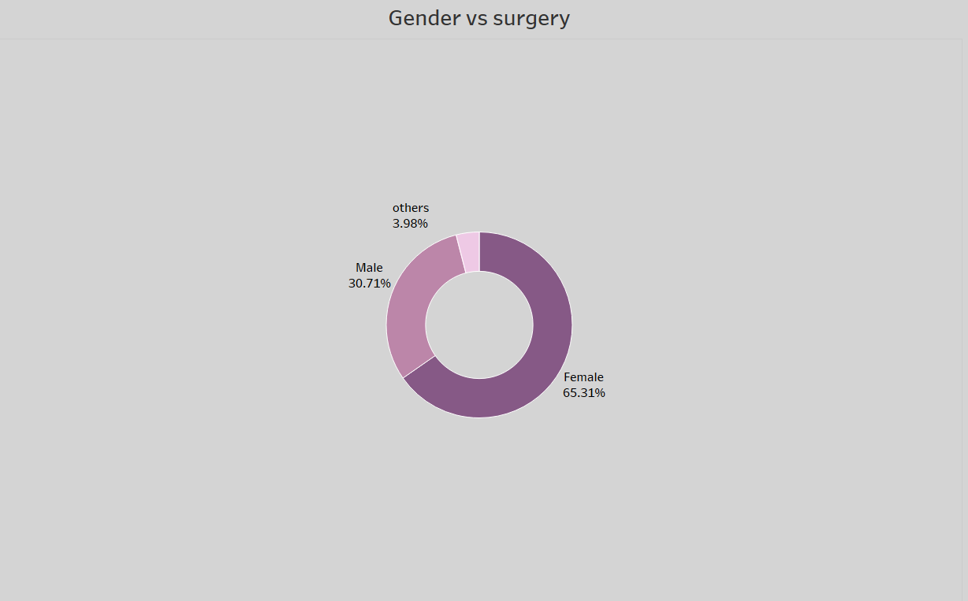

**Activity 1.3:**

**Explanation link**: pregnant by Bloodlevels (T3) using lollipop chart.

[**https://drive.google.com/file/d/1Bi6oRjC4_xYn6KLeexfrGEzF_Y8MUl9U/view?usp=sharing**](https://drive.google.com/file/d/1Bi6oRjC4_xYn6KLeexfrGEzF_Y8MUl9U/view?usp=sharing)

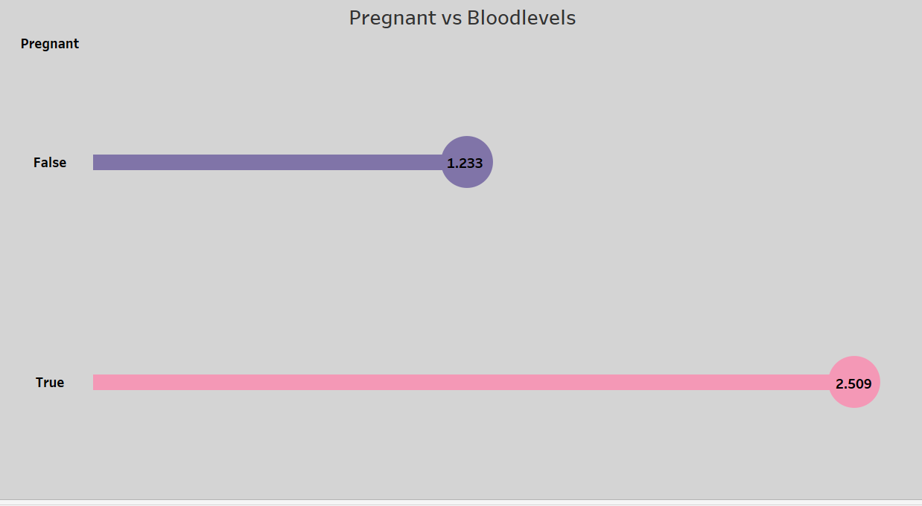

**Activity 1.4:Explanation link:** distribution by age using histogram.

[**https://drive.google.com/file/d/11CxTK3V8PKOL_AJRZOjlsQzHDoVQlWpS/view?usp=sharing**](https://drive.google.com/file/d/11CxTK3V8PKOL_AJRZOjlsQzHDoVQlWpS/view?usp=sharing)

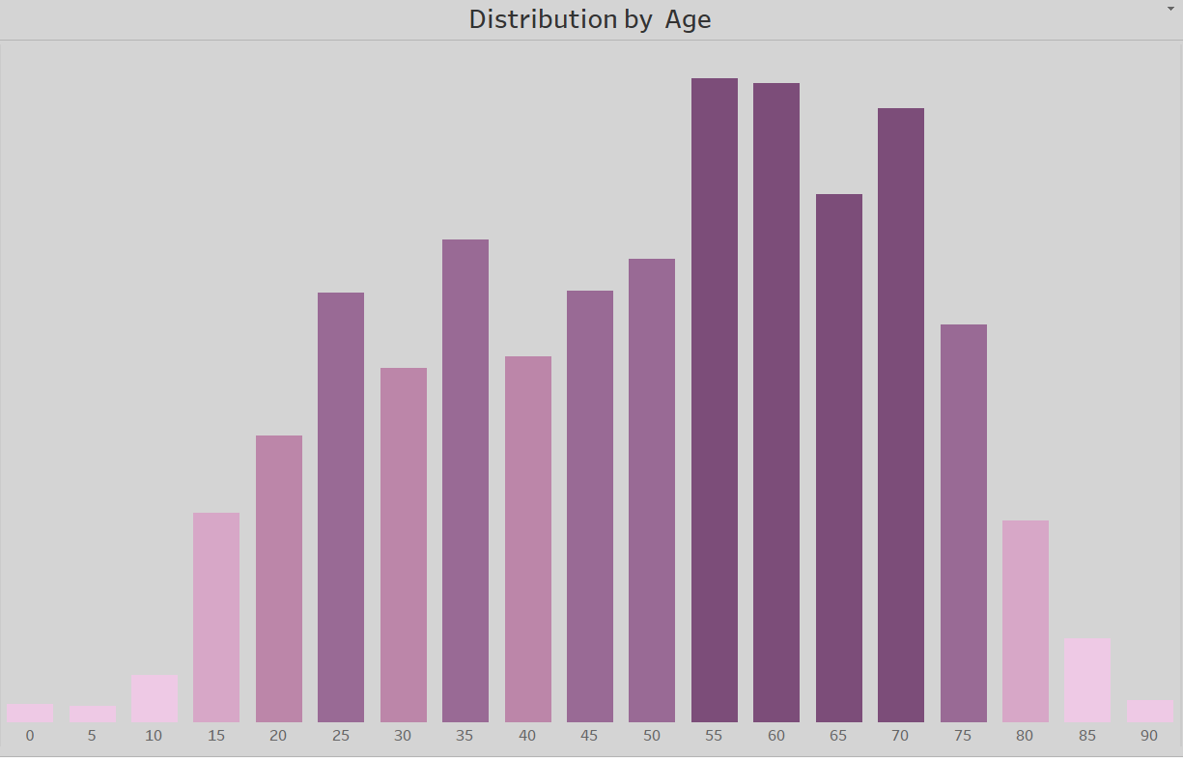

**Activity 1.5:**

**Explanation link:** Age ranges by referral sources using sunburst chart.

[**https://drive.google.com/file/d/1CW8JtLucDKQTqDov118Hd0eazopNgHh0/view?usp=sharing**](https://drive.google.com/file/d/1CW8JtLucDKQTqDov118Hd0eazopNgHh0/view?usp=sharing)

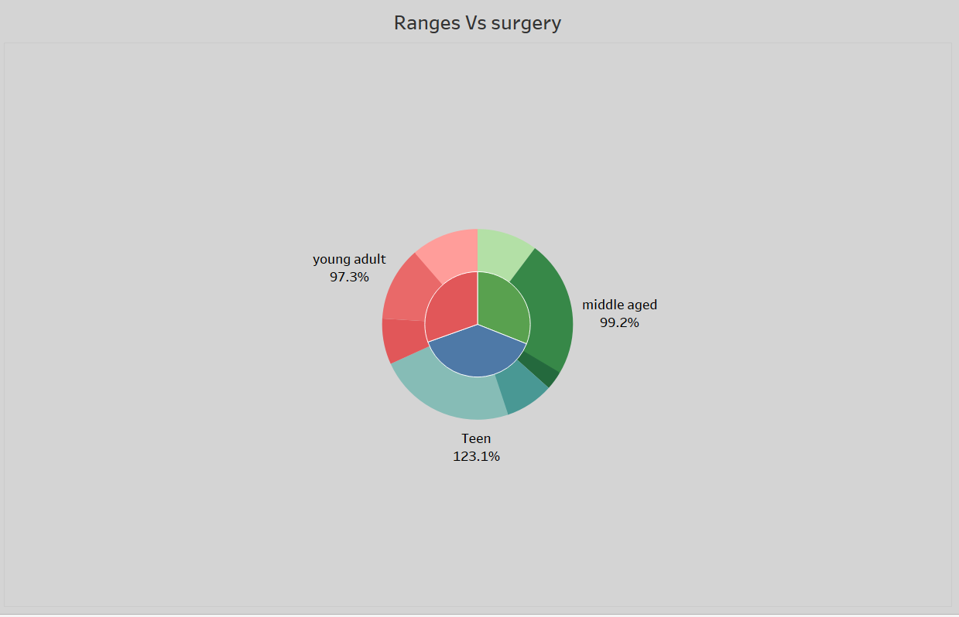

# Milestone 4: Dashboard

A dashboard is a graphical user interface (GUI) that displays information and data in an organized, easy-to-read format. Dashboards are often used to provide real-time monitoring and analysis of data, and are typically designed for a speciﬁc purpose or use case. Dashboards can be used in a variety of settings, such as business, ﬁnance, manufacturing, healthcare, and many other industries. They can be used to track key performance indicators (KPIs), monitor performance metrics, and display data in the form of charts, graphs, and tables.

## Activity:1- Responsive and Design of Dashboard

The responsiveness and design of a dashboard for Data-Driven insights on **Predictive Analysis of Thyroid disease** is crucial to ensure that the information is easily understandable and actionable. Key considerations for designing a responsive and eﬀective dashboard include user-centered design, clear and concise information, interactivity, a data-driven approach, accessibility, customization, and security. The goal is to create a dashboard that is user-friendly, interactive, and data-driven, providing actionable insights

**Explanation Video Link:** [**https://drive.google.com/file/d/1Hmh8ntP4uNCg-GmbwYJfPzqx4n1va5_i/view?usp=sharing**](https://drive.google.com/file/d/1Hmh8ntP4uNCg-GmbwYJfPzqx4n1va5_i/view?usp=sharing%20%20)

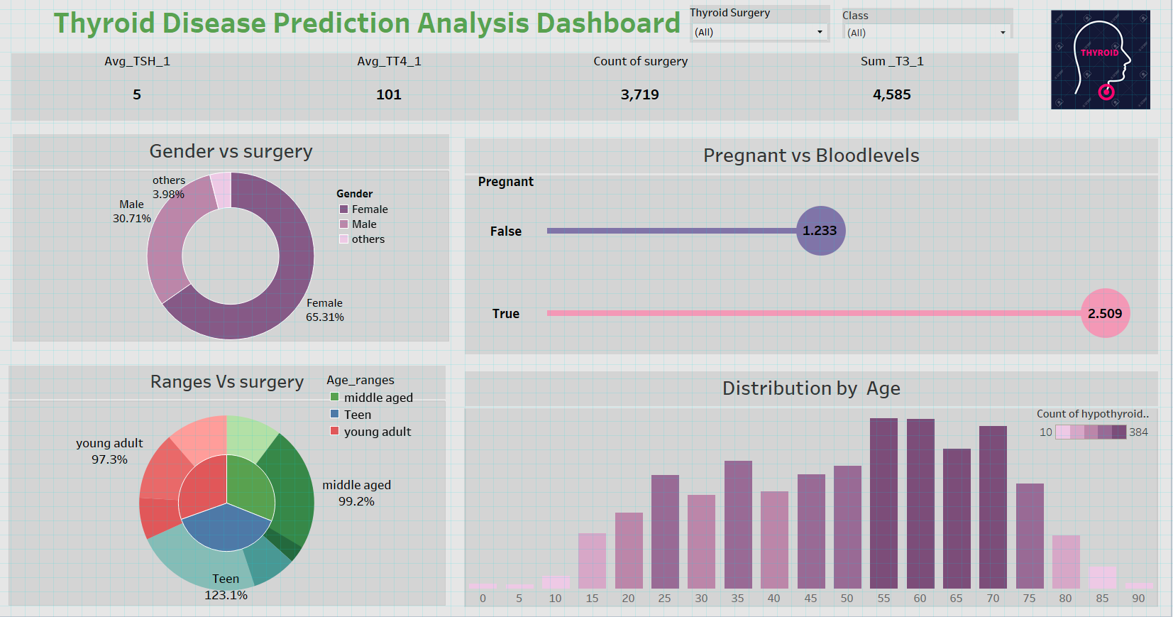

# Milestone 5: Story

A data story is a way of presenting data and analysis in a narrative format, with the goal of making the information more engaging and easier to understand. A data story typically includes a clear introduction that sets the stage and explains the context for the data, a body that presents the data and analysis in a logical and systematic way, and a conclusion that summarizes the key ﬁndings and highlights their implications. Data stories can be told using a variety of mediums, such as reports, presentations, interactive visualizations, and videos.

## Activity:1- No of Scenes of Story

The number of scenes in a storyboard for aircraft models will depend on the complexity of the analysis and the speciﬁc insights that are trying to be conveyed. A storyboard is a visual representation of the data analysis process and it breaks down the analysis into a series of steps or scenes.

**Explanation video link:**

[**https://drive.google.com/file/d/1-JDAnjoPb3awmYi7JXRIat_HDoQlZ-gX/view?usp=sharing**](https://drive.google.com/file/d/1-JDAnjoPb3awmYi7JXRIat_HDoQlZ-gX/view?usp=sharing)

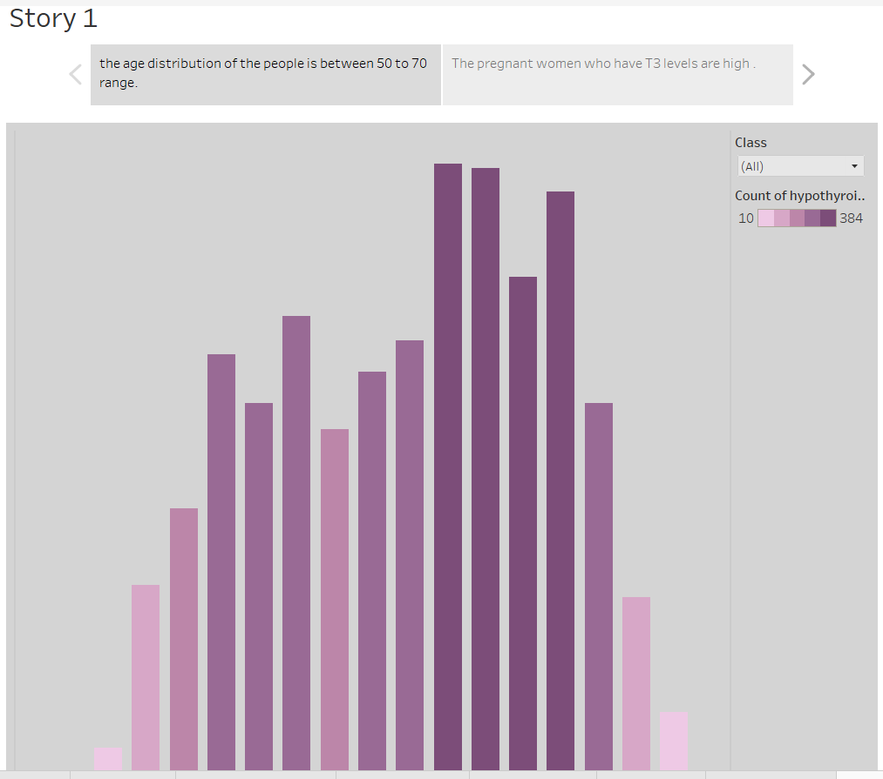

# Milestone 6: Performance Testing

## Activity 1: Utilization of Filters:

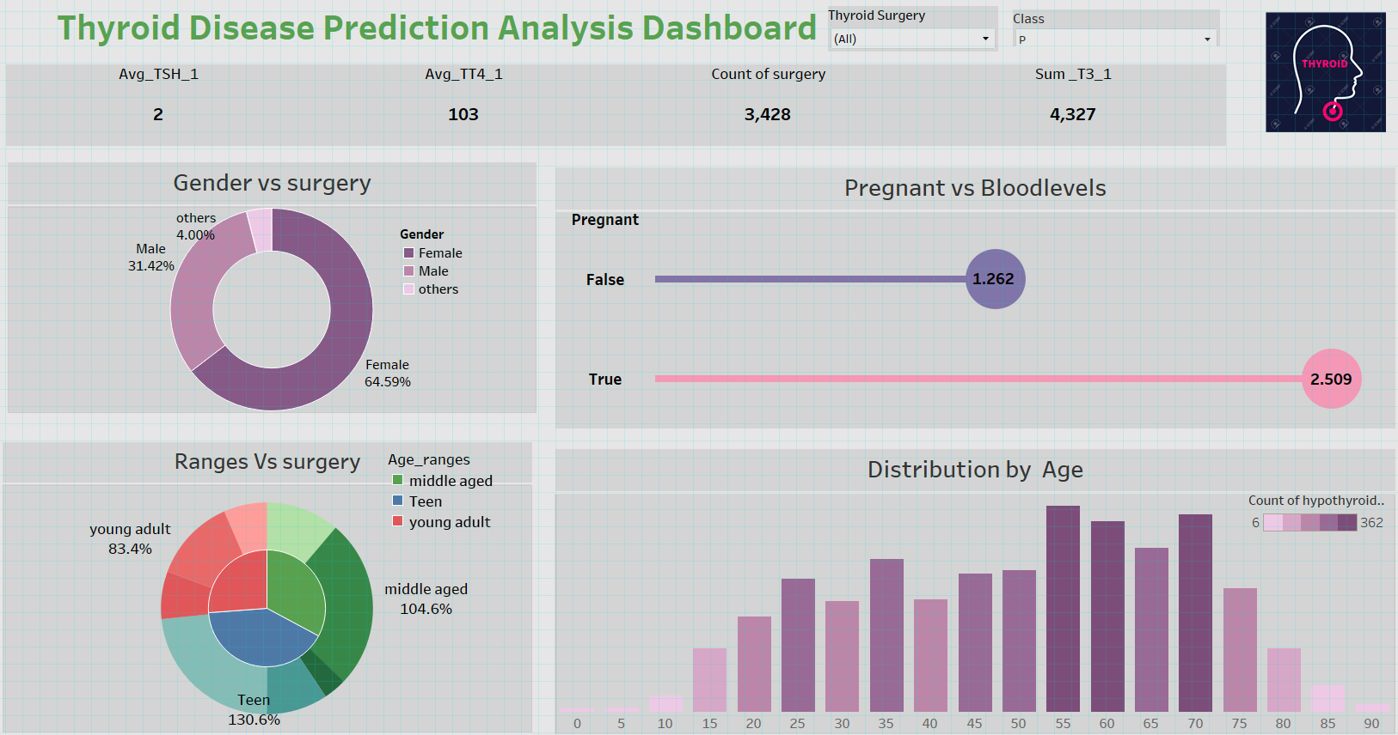

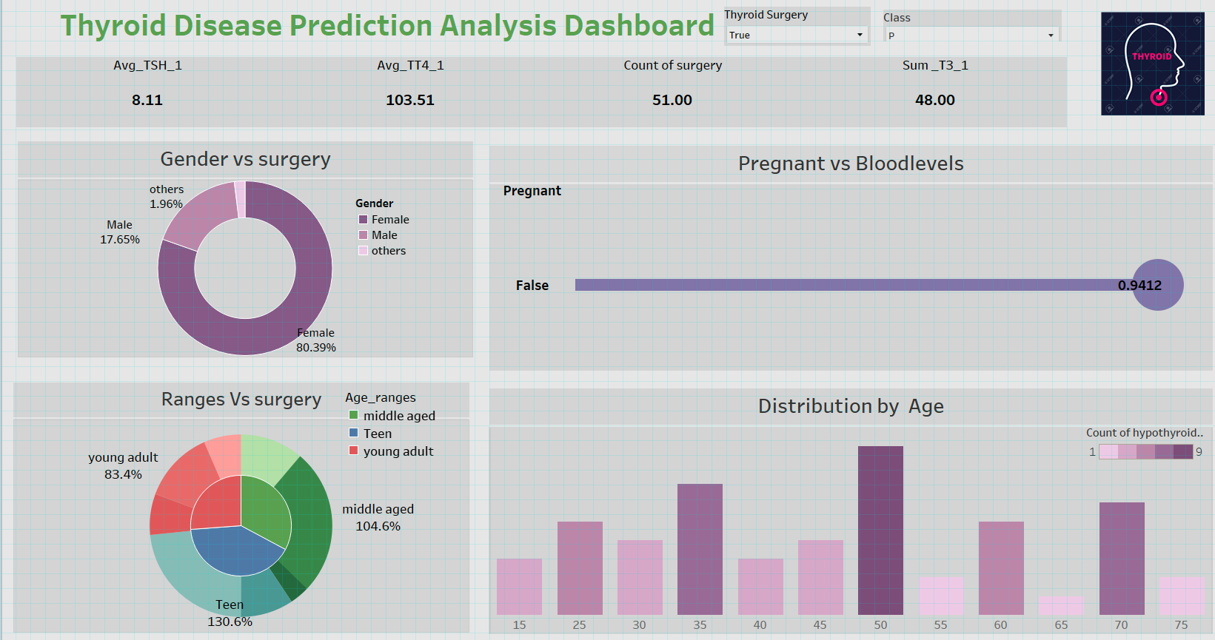

**Activity 2: No of Calculation Fields**

* Age ranges
* Gender
* Surgery
* T3_1
* TT4_1
* Age(bin)

## Activity 3: No of Visualizations/ Graphs

* gender by surgery rate using donut chart.
* pregnant by Bloodlevels (T3) using lollipop chart.
* Distribution by age using histogram.
* Age ranges by referral sources using sunburst charts.

# Milestone 7: Publishing

Publishing helps us to track and monitor key performance metrics, to communicate results and progress. Help a publisher stay informed, make better decisions, and communicate their performance to others.

### Publishing dashboard and reports to tableau public

Step 1 Go to data Source and Select Extract so that .hyper extension files are created and save it at your desktop.

(please wait for pop up of file to save)

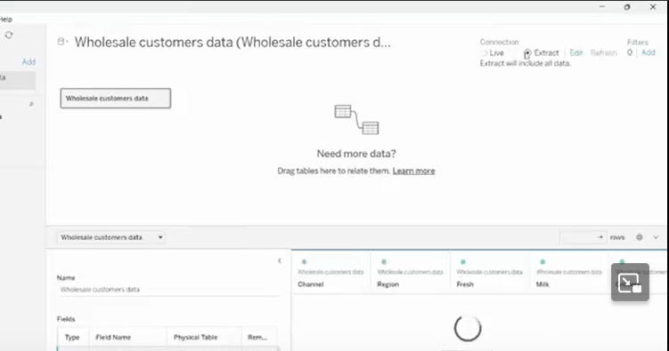

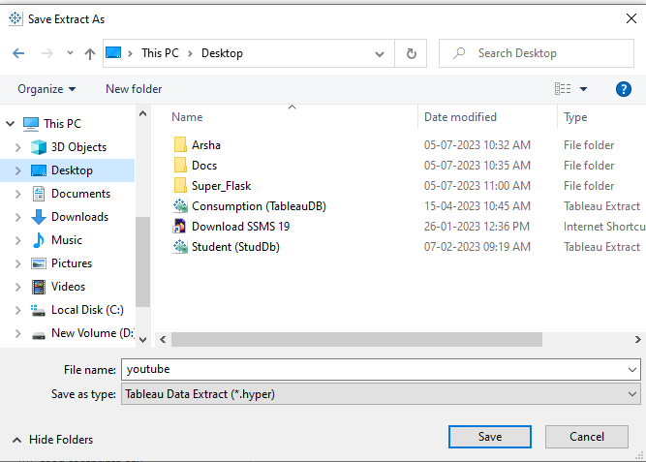

Step 2: Go to Dashboard/story, click on share button on the top ribbon

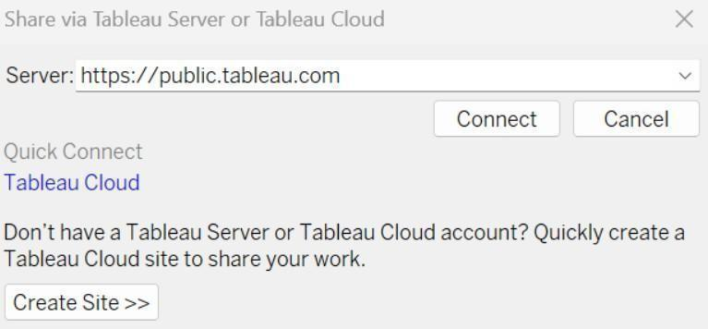

Give the server address of your tableau public account and click on connect.

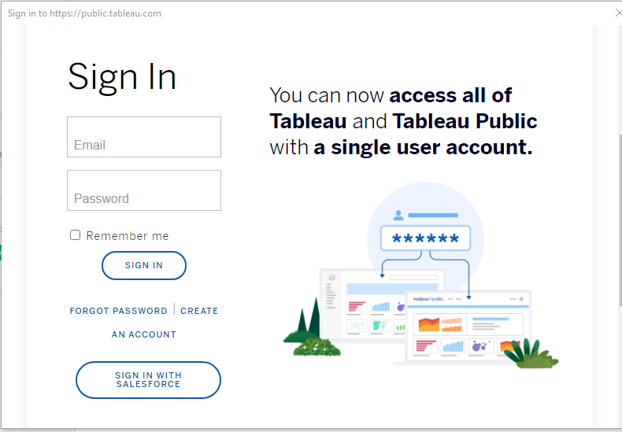

Sign in to your Tableau Public account or create a new account if you don't have one. You can visit the Tableau Public website (public.tableau.com) and click on the "Sign In" or "Join" button.

In the "Tableau Public Sign In" window, enter your Tableau Public account credentials and click "Sign In."

Next, you'll need to provide a title and description for your workbook. Fill in the appropriate details in the provided field of workbook Title

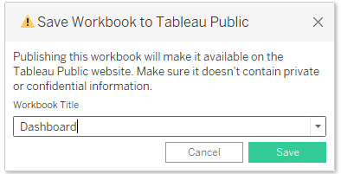

Click on the "Save" button to start the publishing process. Tableau Desktop will upload your workbook to Tableau Public.

Once the upload is complete, a browser window will automatically open, displaying your published workbook on Tableau Public. Review the workbook to ensure that everything appears as expected.

**Reference video link:**

[**https://drive.google.com/file/d/1RSSbIiEDVtkLUa4VzrdawcEH4QwVNaCq/view?usp=sharing**](https://drive.google.com/file/d/1RSSbIiEDVtkLUa4VzrdawcEH4QwVNaCq/view?usp=sharing)

So in a similar way we can also publish Story to tableau public.

# Milestone 8: Project Demonstration & Documentation

Below mentioned deliverables to be submitted along with other deliverables.

## Activity 1: Record explanation Video for project end to end solution

Creating a record explanation video for a project's end-to-end solution is crucial for ensuring clarity and transparency in its implementation.

**Activity 2: Project Documentation-Step by step project development procedure**

Create a document as per the template provided.